SonarQube Local Server Installation

- Download and install OpenJDK from https://adoptium.net/en-GB/temurin/releases/?version=17
- Install MS SQL Server and SQL Server Management Studio
- Download SonarQube community build from https://www.sonarsource.com/products/sonarqube/downloads/
- Extract zip file into C:// directory
- Go to \bin\windows-x86-64 within the extracted folder and run StartSonar.bat in CMD with admin rights
- Once the server starts, go to localhost:9000 in your browser
- Create a project locally from the SonarQube server interface
- In the step prompting for Analysis method, choose the option ‘locally’ 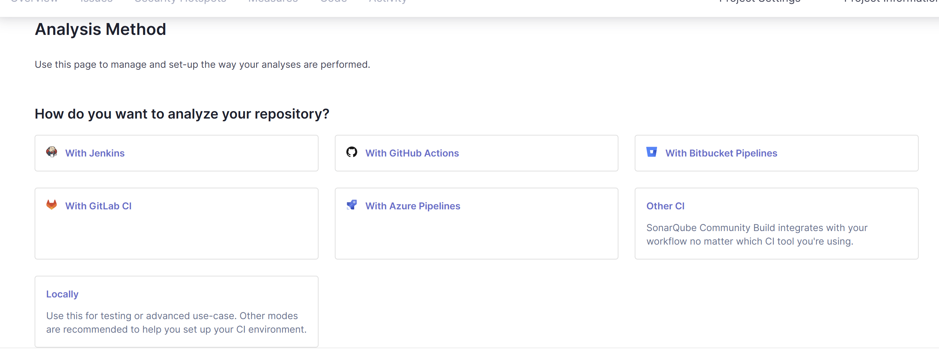
- Generate a project token
- Select the project language and your system OS
- Now, let’s download the scanner to scan our codebase from this link https://docs.sonarsource.com/sonarqube-community-build/analyzing-source-code/scanners/sonarscanner/
- Extract the zip into C:// directory
- Add the bin folder inside it to your ENV variables
- Now, we are ready to run the scanner. Go to the project codebase directory, open CMD with admin rights and run the command generated in step 10 UI (under ‘Execute the Scanner’ subsection). 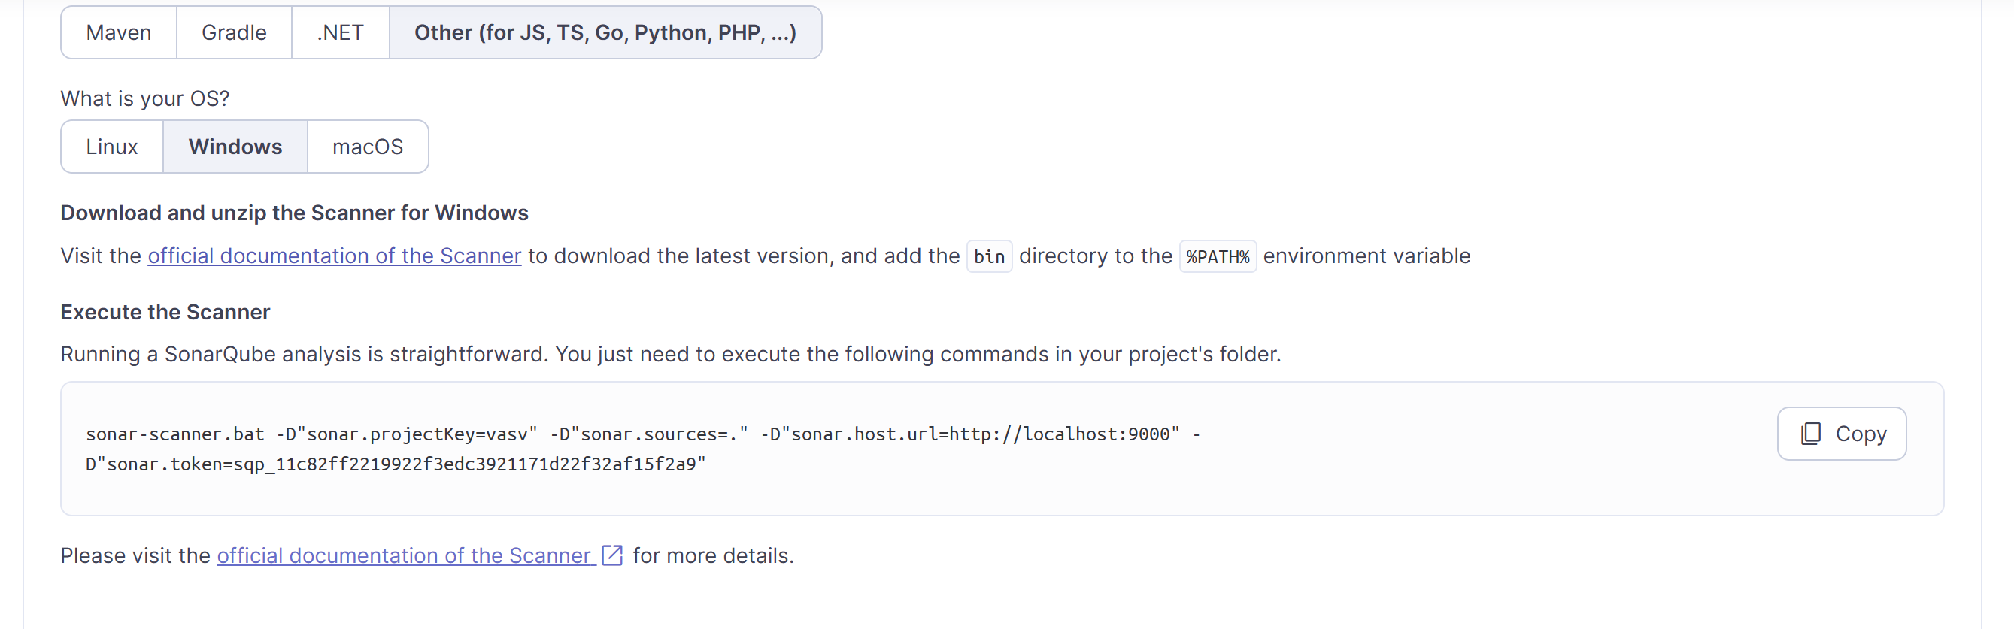
- Once the scanner finishes execution in CMD, the analysis results get updated in the SonarQube server UI 